Nama : M. Danu Hidayat
Rombel : TJKT XI-2
- Debian 11
Settings Ip address  Nano /etc/network/interfaces  Lalu restart systemctl restart networking | 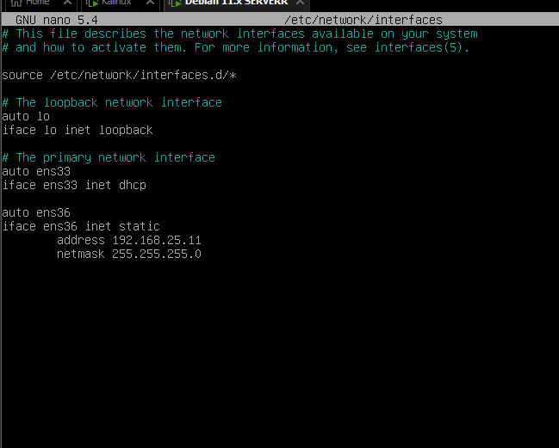
Lalu connectkan antara Debian dengan windows | 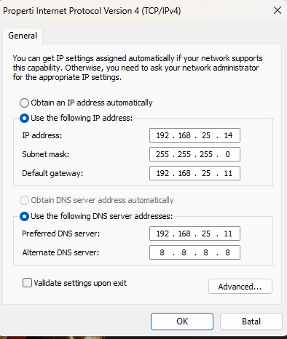
Install vsftpd sudo apt install vsftpd -y | 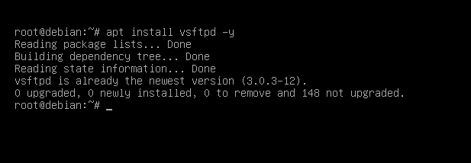
Hapus semua lalu isi dengan  Di dalam  Nano /etc/vsftpd.conf  listen=YES  listen_ipv6=NO  anonymous_enable=NO  local_enable=YES  write_enable=YES  local_umask=022  dirmessage_enable=YES  use_localtime=YES  xferlog_enable=YES  connect_from_port_20=YES  xferlog_file=/var/log/vsftpd.log  xferlog_std_format=YES  chroot_local_user=YES  secure_chroot_dir=/var/run/vsftpd/empty  pam_service_name=vsftpd  rsa_cert_file=/etc/ssl/certs/ssl-cert-snakeoil.pem  rsa_private_key_file=/etc/ssl/private/ssl-cert-snakeoil.key  ssl_enable=NO  allow_writeable_chroot=YES  pasv_enable=YES  pasv_min_port=40000  pasv_max_port=40100  pasv_address=192.168.27.254  userlist_enable=YES  userlist_file=/etc/vsftpd.userlist  userlist_deny=NO | 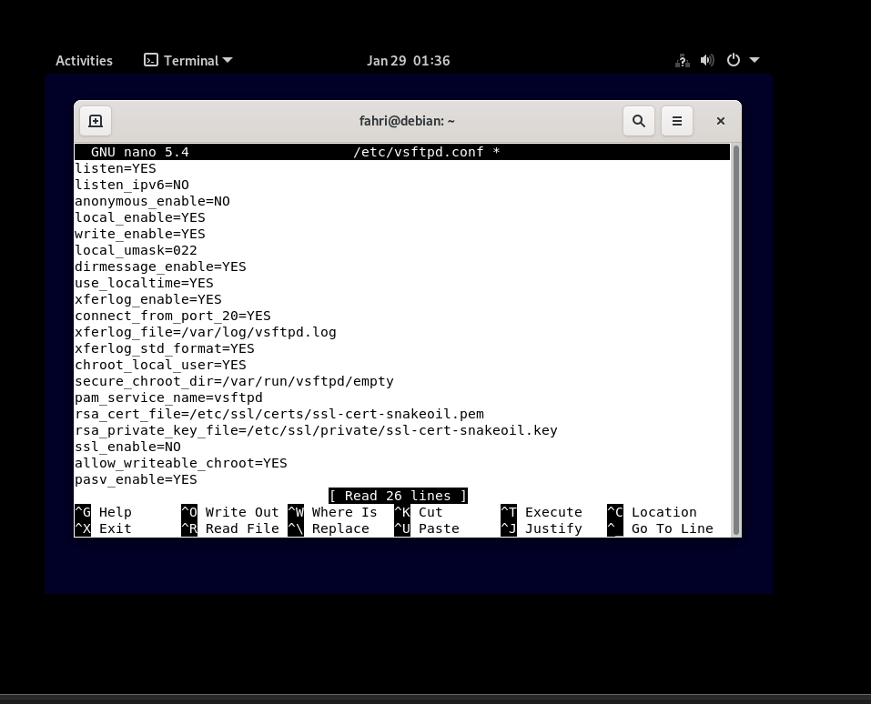
Trambahkan user guru  sudo useradd -m -s /bin/bash guru  echo "guru:guru123" | sudo chpasswd | 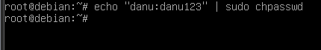
Lalu setup directory  sudo mkdir -p /home/guru/ftp/files  sudo chown nobody:nogroup /home/guru/ftp  sudo chmod a-w /home/guru/ftp  sudo chown guru:guru /home/guru/ftp/files | 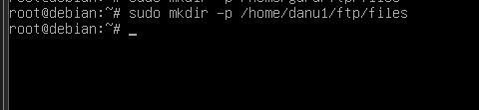
Tambahkan user ke list  echo "guru" | sudo tee /etc/vsftpd.userlist | 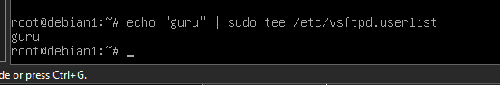
Lalu restart
Install apache2  sudo apt install apache2 apache2-utils -y | 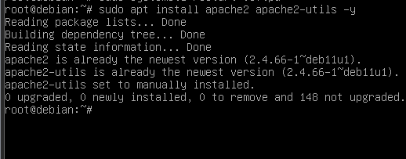
sudo mkdir -p /var/www/html/download  sudo htpasswd -c /etc/apache2/.htpasswd admin | 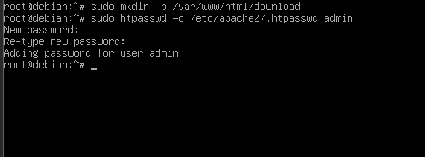
sudo nano /var/www/html/download/.htaccess | 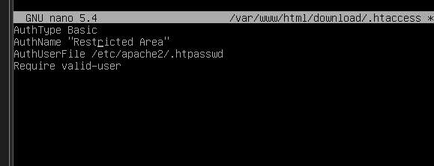
LALU RESTART | 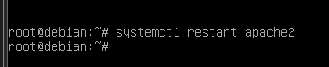
Install monitoring | 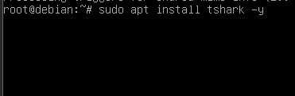
 | 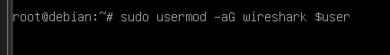
sudo apt install ufw -y  sudo ufw default deny incoming  sudo ufw default allow outgoing  sudo ufw allow 22/tcp  sudo ufw allow 21/tcp  sudo ufw allow 80/tcp  sudo ufw allow 40000:40100/tcp  echo "y" | sudo ufw enable  sudo ufw status | 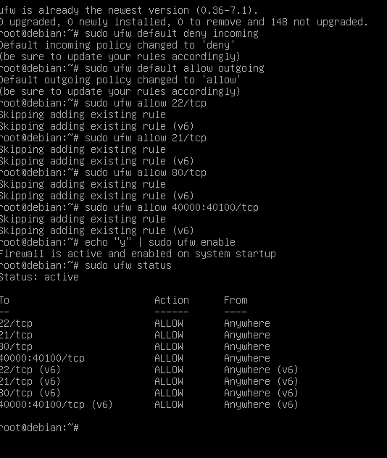
sudo nano /etc/sysctl.conf | 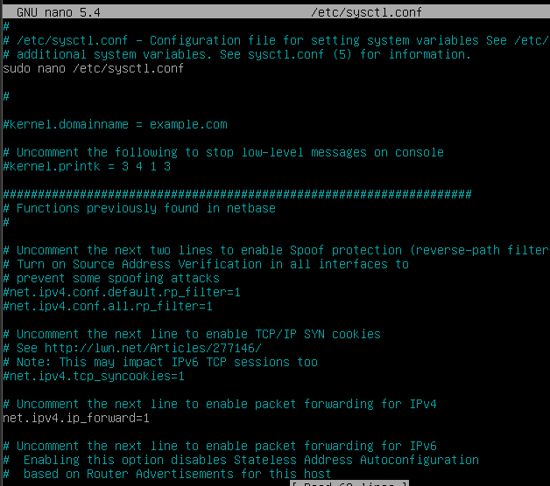

- Kali Linux
Setting ip | 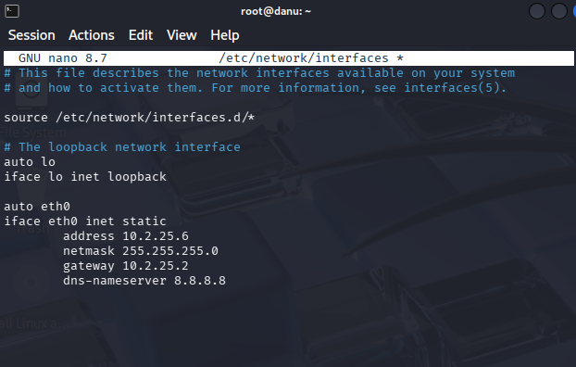
Lalu restart | 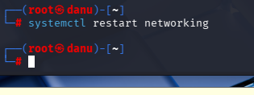
Tambahkan nameserver 8.8.8.8 di resolv.conf | 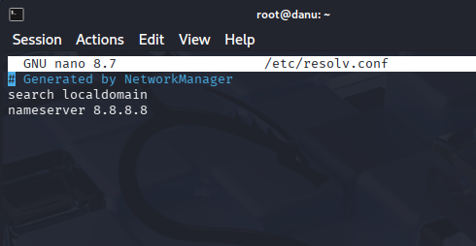
Apt update | 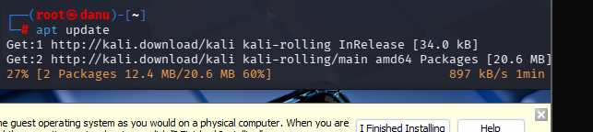
Install wireshark | 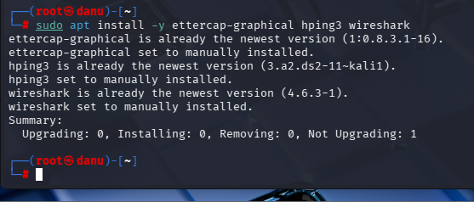

- Windows
Ping 192.168.27.254 | 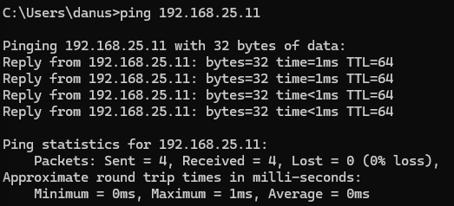
ping 192.168.27.100 | 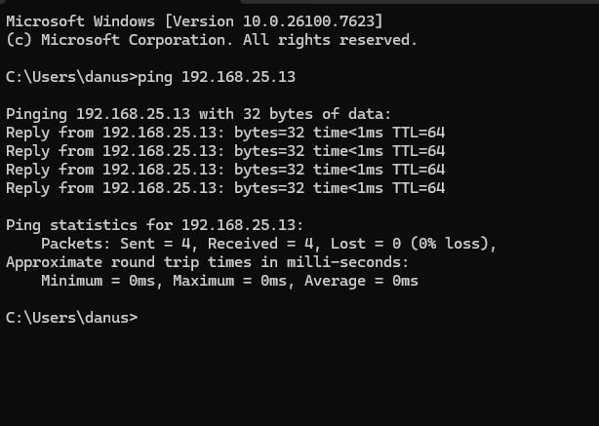
Test ftp menggunakan cmd dengan user guru dan pw guru123 | 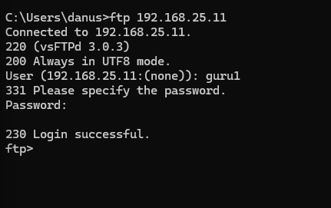

- Tes di Debian 11
Ping 192.168.27.100 | 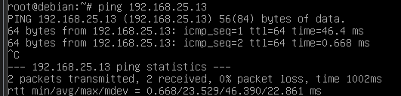
Ping 192.168.27.1 | 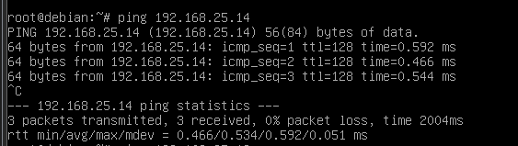

- Tes di kali linux
Ping 192.168.27.254 | 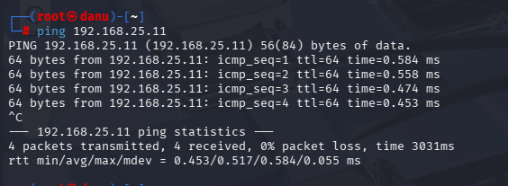
Ping 192.168.27.100 | 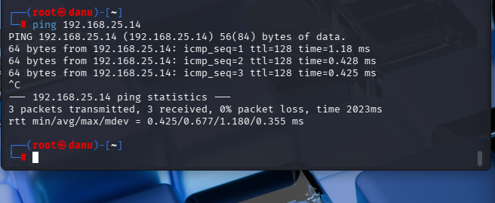
 | 
Lalu kit ates di Ettercap kali linux tapi sebelum itu kita login dulu di cmd | 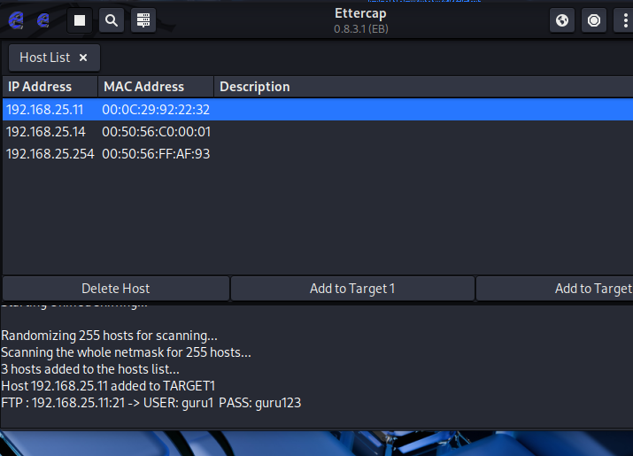
Jalankan tshark | 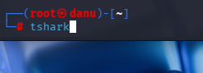
 | 